Dark Chocolate with Blueberries :

Save our Sea Turtles

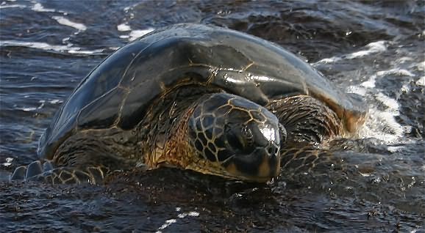

Theresa L. Ford
April 26, 2005

for

University of Maryland University College
Environment and Ecosystems Management
(ENMT 301)
Sabrina Fu

INTRODUCTION

PART 1: Sea Turtles

1. Basic Taxonomy
2. Life Cycle
3. Habitats

PART 2: Plight

1. Population Statistics

2. Habitat Destruction
3. Harvesting
4. Incidental Slaughter - Netting and Longline Fishing
5. Consequences of Reduced Population

PART 3: What is Being Done

1. Conservation Methods
2. International Protection
3. Publicity

PART 4: Recommendations

CONCLUSION

REFERENCES

APPENDIX
INTRODUCTION
The Endangered Species Chocolate Company makes a dark chocolate and blueberry candy bar named "The Sea Turtle Bar". The back of its wrapper describes sea turtles while a portion of its sales profits goes toward endangered species research. All species of sea turtles are listed as threatened or endangered on the U.S. Federal Endangered Species Act. While a candy bar can raise awareness, it will not save the sea turtles.
This paper describes these beautiful creatures, their plight, and what can be done to save them from extinction. The first part of the paper describes the sea turtles, their life cycle and habitats. The second part reviews their plight and why they are on the endangered species list. The last part describes what is being done to protect and support sea turtles and offers recommendations.

PART 1: Sea Turtles
1. Basic Taxonomy
Sea turtles (also called marine turtles) are reptiles that spend almost all of their lives in oceans around the world. There are seven species of sea turtles - leatherback, loggerhead, green sea, hawksbill, kemp's ridley, olive ridley, and flatback. (Caribbean Conservation Corporation & Sea Turtle Survival League, 2005)
Sea turtles are identified by their head, shell (carapace), and underside (plastron). Their heads have beaks (rhampotheca) instead of mouths and teeth, and their eardrums are completely covered over. In all but the leatherback, sea turtles have distinguishing prefrontal scales and the carapace and plastron are divided into plate-like segments called scutes. (Wyneken, 2001) See the Appendix for individual species identification. Sometimes sea turtles are split into 10 different species, but this is still being debated because interspecies breeding blurs the distinction. (Hey, 2005)
2. Life Cycle
Sea turtles begin their lives by using their egg-tooth (caruncle) to break out of their egg. At the same time as their siblings, they dig out of their sand nest and crawl toward the lights and sounds of the ocean. In the ocean, we lose track of them for several years (called their "lost years") where they likely drift with floating seaweed until they are large enough to survive the predators at their grazing ground in the shallow water. (Cerullo, 2003)
Depending on their beak type, sea turtles eat jelly fish, sea cucumbers, mollusks, prawns, bryozoans, seaweed, invertebrates, crustaceans, tunicates, fish, shrimp, clams, sea urchins, squid, sponges, anemones, worms, grasses, aquatic insects, algae, and horseshoe crabs. (Caribbean Conservation Corporation & Sea Turtle Survival League, 2005)
Sea turtles live in the ocean, swimming in currents and resting or sleeping on the surface or bottom. When they are adults and ready to mate, both the male and females migrate to their natal beach. The female crawls ashore, digs a nest, lays her eggs, and returns to the ocean. (Caribbean Conservation Corporation & Sea Turtle Survival League, 2005)
3. Habitats
Sea turtles nest on beaches in the Earth's tropical and subtropical zones from about 30 degrees south to 30 degrees north of the equator. They migrate farther north and south and across the oceans in their quest for food and will only return to their natal beach when they are ready to mate. (Hey, 2005) While the flatback sea turtle lives around Australia and Papua New Guinea, the leatherback is found in every ocean on the Earth. (Caribbean Conservation Corporation & Sea Turtle Survival League, 2005)

PART 2: Plight
1. Population Statistics
Only about 1 in 1000 sea turtles actually survive to adulthood. At all stages of life, sea turtles are threatened both by nature and natural predators. Population estimates by species range from less than 1000 (Kemp's Ridley) to 800,000 (Olive Ridley). These statistics are determined by the amount of turtles nesting, as actual count in the ocean is not possible. (Caribbean Conservation Corporation & Sea Turtle Survival League, 2005)

Population estimates based on nesting turtles reflect the state of the environment and dangers to sea turtles at the time of their birth, 20-50 years ago. Current changes in habitat and environment and how they affect the species populations may not be apparent for another 25 years. (Klemens, 2000, p. 101)
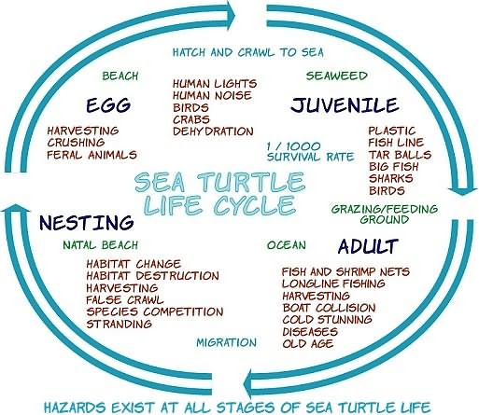

2. Habitat Destruction

Erosion and weather (like hurricanes) can destroy or change beaches. Humans also change beaches. The beaches are barricaded off to prevent erosion, developed with buildings, made safe for boats with the construction of harbor sea walls and piers, turned into high-traffic tourist locations, or polluted beyond usability. Besides noting that sea turtles are not likely to nest (and perpetuate the population) if their natal beach is unavailable, human lights disorient newly hatched turtles causing them to crawl away from the water. Tourist traffic can compress and smash eggs. (Hey, 2005) (Harless & Morlock, 1979, p. 531)
Additionally, marine ecosystems are being polluted and destroyed. Coral reefs, for example, are an important habitat for three species of sea turtles. (Klemens, 2000, p. 106) Plastic bags are mistaken for jelly fish (one of the food sources for sea turtles). Fish line can tangle sea turtles and drown them. (Caribbean Conservation Corporation & Sea Turtle Survival League, 2005)
3. Harvesting
Sea turtles are an excellent source of protein in the diets of some cultures. They are also used in religious ceremonies and to make decorative items. For example, the hawksbill turtle is used to make tortoise shell trinkets like jewelry and ornaments. Sea turtles can be legally harvested in some countries. Where it is illegal, enforcement is often lacking. (Klemens, 2000, p. 104)
Archie Carr, whose book on sea turtles eventually led to the creation of the Caribbean Conservation Corporation, describes how sea turtles were easily kept alive on their backs in ships on long journeys so that they could be fresh food for sailors. Carr's favorite sea turtle dish was stewed fins. (Carr, 1967, p. 13-19)
4. Incidental Slaughter - Netting and Longline Fishing
Shrimp nets are currently the main threat to sea turtles. Shrimp nets are dragged along the bottom of the ocean and catch everything in their path, including sea turtles. In the nets, sea turtles can not surface for air and subsequently drown. (Hey, 2005)
Conservationists have tried to help with the invention of turtle excluder devices (TEDs) for shrimp nets. These devices are attached to the neck of the nets and have gaps large enough for shrimp, but too small for other marine animals, which can then escape through a hole at the top or bottom of the device. When sea turtles bump into the TED, it opens a hole, and they can escape. (Hey, 2005)
The quest for commercial seafood with longline fishing also kills sea turtles. Extremely long floating lines are extended across 40-60 miles, with intervals of baited hooks attached to shorter lines that descend into the water. Modifying the hooks to make them more round would cut down on the capture of sea turtles. (Hey, 2005)
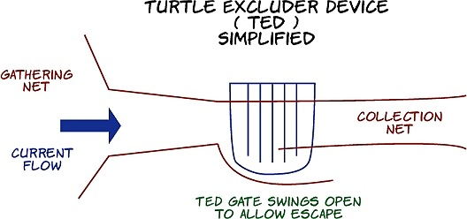
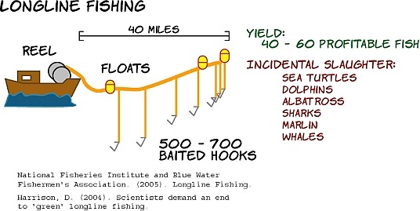
5. Consequences of Reduced Population
Not only are sea turtles a major part of some diets, but if sea turtles cease to exist, we would lose a vital part of our coral reef ecology. Sea turtles help control the growth of grasses and sea life on our already stressed coral reefs. (Hey, 2005)
Sea turtles are also a major source of knowledge we have yet to discover. They are the oldest living fossil, reaching back 250 million years to their ancestor, the proganochelys. They are the only class in the animal kingdom with a plastron. How did sea turtles evolve? How did they survive the extinction of the dinosaurs? Do sea turtles sense magnetic fields and navigate the globe using them? How do they find the exact beach where they hatched? How do females know the exact location of the nest they laid a year ago? Where do hatchlings go during their first years? These are questions that still need research. (Hey, 2005)

PART 3: What is Being Done
1. Conservation Methods
The World Conservation Union Marine Turtle Specialist Group contends that unless conservation actions are taken, sea turtles will become extinct. Their seven part global strategy to save the sea turtles focuses on scientific research, awareness, education, and global cooperation. (Klemens, 2000, p. 107)
Conservation methods have been mostly geared around infant sea turtles mainly because that is where most contact with sea turtles is and because it can be handled locally instead of internationally. Conservation methods of infant sea turtles include captive rearing - headstarting, ranching, and farming. (Klemens, 2000, p. 107-123)
Each of these methods have problems that cause debate about their effectiveness. Headstarting is gathering eggs and raising the turtles in captivity and then releasing them. In addition to a greatly reduced hatchling survival rate, differing temperatures cause skewed gender ratios. Sea turtles raised in captivity are not as able to survive in the wild. Also, captive-bred sea turtles are prone to diseases that can spread to wild populations. Genetic mixing of sea turtles in captivity may cause adaptation and research problems. (Klemens, 2000, p. 107-123)
In ranching, eggs are gathered, sea turtles are raised and then slaughtered. In farming, eggs come from captive sea turtles. Raising sea turtles costs more money for facilities, water purification, and food than can be made selling products from the raised turtles. Even if some of the sea turtles are released into the ocean to try and sustain the wild sea turtle population, they are unlikely to survive to adulthood. (Klemens, 2000, p. 107-123)
Sea turtle rescue, relocating eggs by digging them up, quickly and carefully transporting them into a safe zone, and reburying them reduces the chance of hatching by 30%. This reduced rate may not be sufficient to have survivors from natural predators. (Harless, Morlock, 1979, p. 528-529)
Therefore conservation methods should be focus on reducing human impact on wild sea turtles, from habitat preservation to reducing incidental slaughter through nets and longline fishing. (Klemens, 2000, p. 107-123) Because sea turtles are migratory, these impacts span the globe. For example, mitochondria DNA testing has shown that Pacific loggerheads that nest in Japan and Australia are the same turtles that are found at Baja, Mexico. (Wuethrich, 1996, p. 44-51)

2. International Protection
Regional and International Organizations and universities coordinate research and rescue efforts and propose international agreements for governments to act on. The more prominent of these are the World Conservation Union, the Environmental Protection Agency, World Wildlife Fund, International Sea Turtle Society, Caribbean Conservation Corporation, and the Sea Turtle Restoration Project. (Hey, 2005)
Treaties such as the Convention on International Trade in Endangered Species, which deals with international wildlife trade, and the Convention on Migratory Species, which regulates the local use of endangered species, work together to try to protect endangered animals. (Hykle, 2002)
In the United States, laws have been passed that require TEDs on all shrimp nets used in certain regions or that catch shrimp to be imported from specific countries. Naturally, shrimp fishermen object because it requires additional hardware and, improperly used, may reduce the intended catch. Officials object to some countries and not others being held to the regulation. Conservationists think the regulations are not monitored nor enforced well enough. (Sea Turtle Restoration Project, 2005) (Hey, 2005)

3. Publicity
Information about sea turtles is spread through publications, the Internet, and annual gatherings or symposiums. Resources include the Marine Turtle News Letter, Copeia, Chelonian Review, the Sea Turtle Restoration Project's Internet mailing list (http://www.seaturtles.org/joinlistserv.cfm), and HERPDIGEST (http://www.podarcis.nl). Regional and international meetings occur at least yearly.

PART 4: Recommendations
Without adequate conservation, I believe sea turtles will become extinct. Full international effort toward conservation methods and enforcing regulations at all stages of sea turtle life is needed. As we save sea turtles, we also sustain a food source and protect our ocean and coral reef habitats. The other option is to acknowledge that sea turtles will become extinct and direct all our resources toward researching and documenting them for future generations.

CONCLUSION
A very unique creature linking to the archaeological past is on the verge of extinction because of habitat changes and life cycle interruptions by humans. The sea turtle is uniquely important to the ocean ecology as well as being part of our food supply. People recognize that unless more is done, we will lose them forever. I hope we can prevent their loss.
REFERENCES

Caribbean Conservation Corporation & Sea Turtle Survival League. Information on Sea Turtles and Threats to Their Survival. Retrieved on April 20, 2005, from http://www.cccturtle.org/contents.htm

Carr, A. (1967). The Sea Turtle. Texas: University of Texas Press.

Cerullo, M. (2003). Sea Turtles - Ocean Nomads. New York: Dutton Children's Books.

Harless, M. & Morlock, H. (1979). Turtles, Perspectives and Research. New York: John Wiley & Sons.

Harrison, D. (2004). Scientists demand an end to 'green' longline fishing. Retrieved April 21, 2005, from http://www.telegraph.co.uk/news/main.jhtml?xml=/news/2004/11/21/nfish21.xml&sSheet=/news/2004/11/21/ixhome.html

Hey, D. (2005). Interview on April 20, 2005.

Hykle, D. (2002). The Convention on Migratory Species and Marine Turtle Conservation. Retrieved April, 23, 2005, from http://www.arbec.com.my/sea-turtles/douglas.php

Klemens, M. (2000). Turtle Conservation. United States of America: Smithsonian Institution Press.

Meylan, P. (2001). Testudines - Turtles, tortoises and terrapins. Retrieved April 20, 2005, from http://tolweb.org/tree?group=Testudines&contgroup=Amniota

Mitchell, John F., John W. Watson, Daniel G. Foster, Robert E. Caylor. April 1995. The Turtle Excluder Device (TED): A Guide to Better Performance. NOAA Technical Memorandum NMFS-SEFSC-366, 35p.

National Fisheries Institute and Blue Water Fishermen's Association. (2005). Longline Fishing. Retrieved April 21, 2005, from http://www.fishingnj.org/techll.htm

Sea Turtle Restoration Project. (2005). Press Releases. Retrieved April 22, 2005, from http://www.seaturtles.org/press_release2.cfm?pressID=22

World Wild Life Fund. (2005). Marine Turtles. Retrieved on April 18, 2005, from http://worldwildlife.org/turtles/index.cfm

Wuethrich, B. (1996). Into Dangerous Waters. International Wildlife, Volume 26, March-April 1996, p. 44-51. Retrieved April 20, 2005, from WilsonSelectPlus database.

Wyneken, J. (2001). The Anatomy of Sea Turtles. U.S. Department of Congress NOAA Technical Memorandum NMFS-SEFSC-470, 1-172 pp.

The sea turtle pictures on the cover and below are by Richard L. Bliss, retrieved April 19, 2005, from http://www.morguefile.com/archive/?display=1101804029167

http://www.morguefile.com/archive/?display=1101804024246

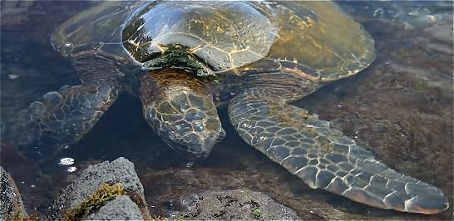

APPENDIX

Sea Turtle Comparison Chart

Common Name | Scientific Name | U.S. Federal Endangered Species Act | International Union for Conservation of Nature and Natural Resources | Population (Estimated by Nesting Females)
Leatherback | Dermochelys coriacea | Endangered | Critically Endangered | 34000
Loggerhead | Caretta caretta | Threatened | Endangered | 60000
Green Sea, Black, Hawaiian Green | Chelonia mydas | Endangered | Endangered | 203000
Hawksbill | Eretmochelys imbricata | Endangered | Critically Endangered | 34000
Kemp's Ridley | Lepidochelys kempii | Endangered | Critically Endangered | <1000
Olive Ridley | Lepidochelys olivaceaf | Threatened | Endangered | 800000
Flatback | Natator depressus | Endangered | Critically Endangered | 7500

(Caribbean Conservation Corporation & Sea Turtle Survival League, 2005)

Sea Turtle Identification Chart

Common Name | Carapace Length | Weight | Head | Carapace | Plastron | Limbs
Leatherback | 4-6 ft | 550-1545 lbs. | No scales | 5 dorsal ridges | No scutes | No claws
Loggerhead | 2.5-3.5 ft | 350 lbs. | More than 1 pair prefrontal scales | 5 lateral scutes | 3 inframarginal scutes without pores | 2 claws on each limb
Green Sea, Black, Hawaiian Green | 3.5-4 ft | 300-400 lbs. | 1 pair prefrontal scales | 4 lateral scutes, color changes with age | 4 inframarginal scutes without pores | 1 claw on each limb
Hawksbill | 2.5-3 ft | 100-150 lbs. | 2 pair prefrontal scales, long narrow beak | 4 lateral overlapping scutes | 4 inframarginal scutes without pores | 2 claws on each limb
Kemp's Ridley | 2 ft | 77-100 lbs. | More than 1 pair prefrontal scales | 5 lateral scutes | 4 inframarginal scutes with pores | 2 claws on each limb
Olive Ridley | 2-2.5 ft | 77-100 lbs. | More than 1 pair prefrontal scales | 6 or more lateral scutes, 6 ore more vertebral scutes | 4 inframarginal scutes with pores | 2 claws on each limb
Flatback | 3.5 ft | 198 lbs.

(Caribbean Conservation Corporation & Sea Turtle Survival League, 2005)

Sea Turtle Chocolate Bar

